MỘT SỐ ĐỒ THỊ TEST
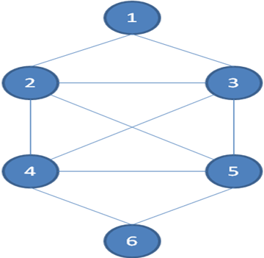
Test1
6
0 1 1 0 0 0
1 0 1 1 1 0
1 1 0 1 1 0
0 1 1 0 1 1
0 1 1 1 0 1
0 0 0 1 1 0
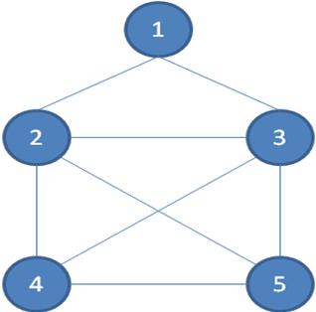
Test 2
5
0 1 1 0 0
1 0 1 1 1
1 1 0 1 1
0 1 1 0 1
0 1 1 1 0
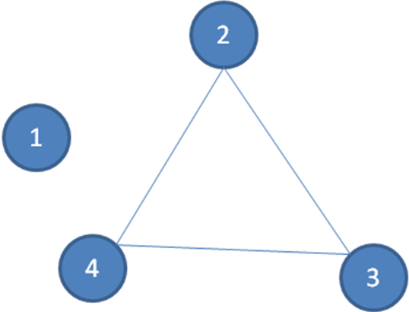
Test 3
4
0 0 0 0
0 0 1 1
0 1 0 1
0 1 1 0

Test 4
6
0 0 0 0 1 1
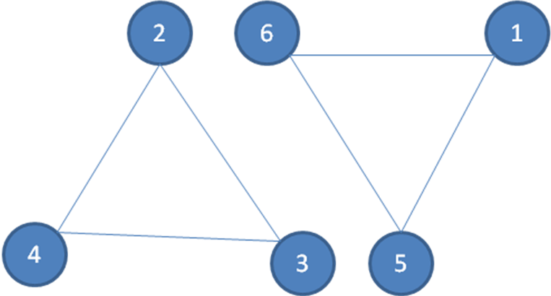
0 0 1 1 0 0
0 1 0 1 0 0
0 1 1 0 0 0
1 0 0 0 0 1
1 0 0 0 1 0

Test 5
8
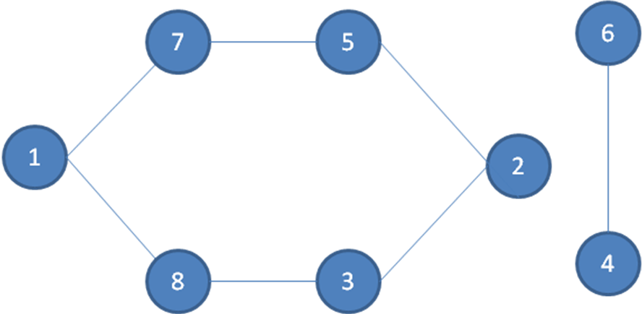
0 0 0 0 0 0 1 1
0 0 1 0 1 0 0 0
0 1 0 0 0 0 0 1
0 0 0 0 0 1 0 0
0 1 0 0 0 0 1 0
0 0 0 1 0 0 0 0
1 0 0 0 1 0 0 0
1 0 1 0 0 0 0 0

Test 6
8
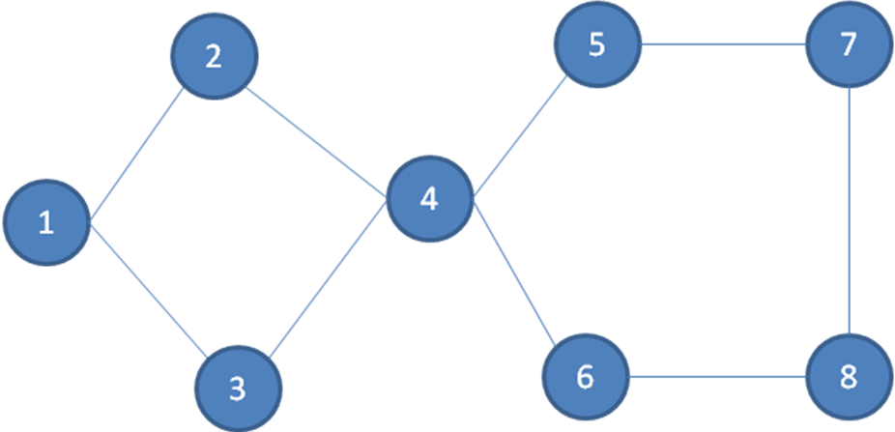
0 1 1 0 0 0 0 0
1 0 0 1 0 0 0 0
1 0 0 1 0 0 0 0
0 1 1 0 1 1 0 0
0 0 0 1 0 0 1 0
0 0 0 1 0 0 0 1
0 0 0 0 1 0 0 1
0 0 0 0 0 1 1 0

Test 7
8
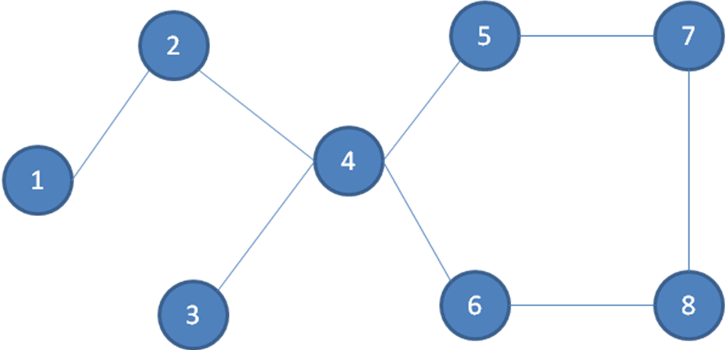
0 1 0 0 0 0 0 0
1 0 0 1 0 0 0 0
0 0 0 1 0 0 0 0
0 1 1 0 1 1 0 0
0 0 0 1 0 0 1 0
0 0 0 1 0 0 0 1
0 0 0 0 1 0 0 1
0 0 0 0 0 1 1 0
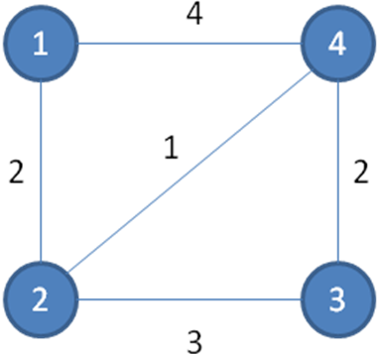
Test 8
4
0 2 0 4
2 0 3 1
0 3 0 2
4 1 2 0
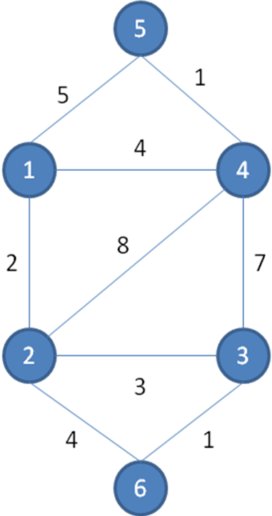
Test 9
6
0 2 0 4 5 0
2 0 3 8 0 4
0 3 0 7 0 1
4 8 7 0 1 0
5 0 0 1 0 0
0 4 1 0 0 0

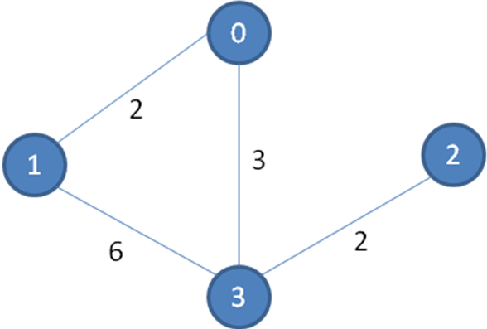
test10
4
0 2 0 3
2 0 0 6
0 0 0 2
3 6 2 0

